DIFFERENT OPERATIONS:

INSTRUCTIONS | Instruction Format
REGISTER – REGISTER ARITHMETIC INSTRUCTIONS
ADD | 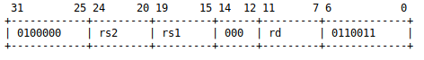
SUB | 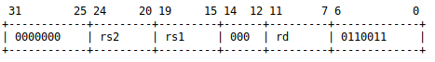
AND | 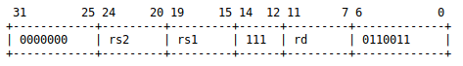
OR | 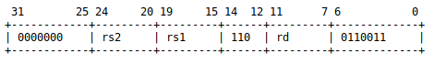
XOR | 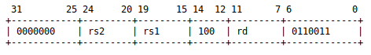
SLT | 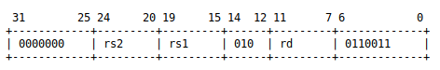
SLTU | 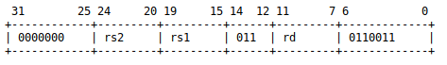
SRA | 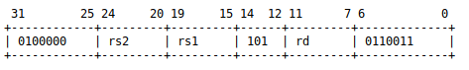
SRL | 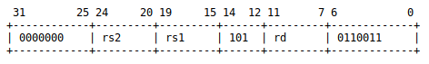
SLL | 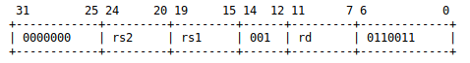
MUL | 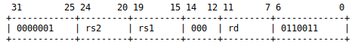
REGISTER – IMMEDIATE ARITHMETIC INSTRUCTIONS
ADDI | 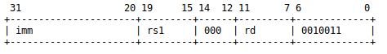
SUBI | 31 20 19 15 14 12 11 7 6 0
  imm | rs1 | 001 | rd | 0010011
ANDI | 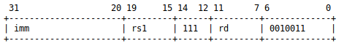
ORI | 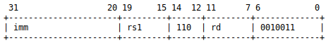
XORI | 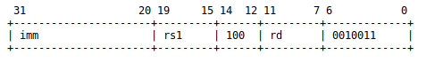
SLTI | 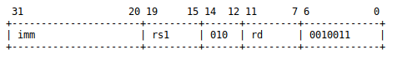
SLTIU | 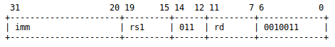
SRAI | 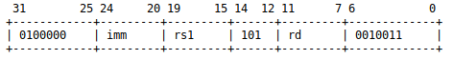
SRLI | 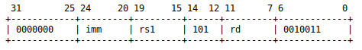
SLLI | 31 25 24 20 19 15 14 12 11 7 6 0
  0000001 | imm | rs1 | 101 | rd | 0010011
LUI | 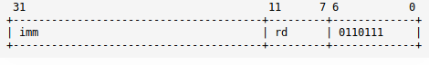
AUIPC | 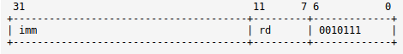
Memory Instructions
LW | 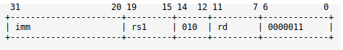
SW | 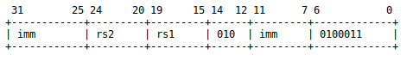
UNCONDITIONAL JUMP INSTRUCTIONS
JAL | 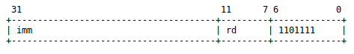
JR | 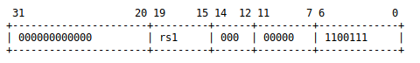
JALR | 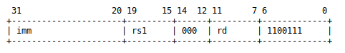
CONDITIONAL BRANCH INSTRUCTIONS
BEQ | 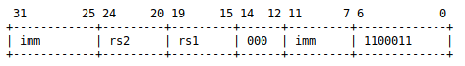
BNE | 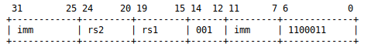
BLT | 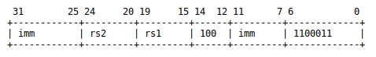
BGE | 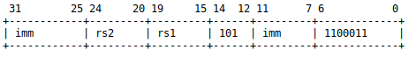
BLTU | 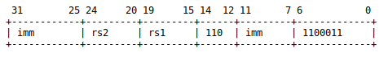
BGEU | 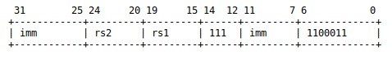
Table3 – Different instructions present and instruction format of each instruction

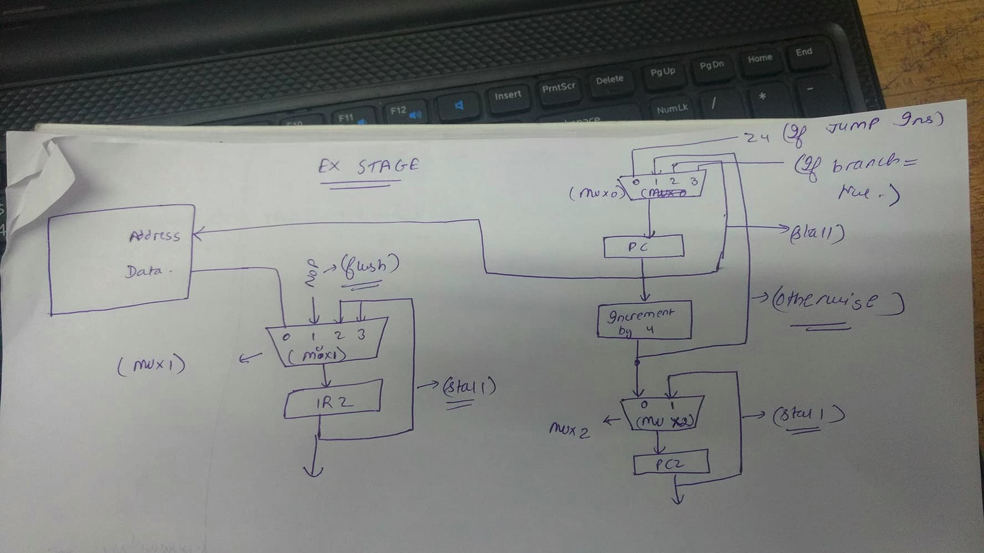

Control Instructions :

(Mux 0) PC MUX :

Select = 0 - Z4 – (IF JUMP INSTRUCTION IN EX STAGE)
Select = 3 - Temp Register (IF BRANCH== TRUE in Ex stage )
Select = 2 - Old PC (If stall has to be there)
Select = 1 - Otherwise

Select = 0 - Zump in Ex stage

(IR3[6:0] = 1100111) || (IR3[6:0] = 1101111)

Select = 2 - Old PC (if stall has to be done)

LW + JALR Lw rd,imm(rs1)
JALR rs1,rd,imm

(IR2[19:15] == IR3[11:7]) & (IR3[14:12] == 010) & (IR3[6:0] == 0000011)
& (IR2[6:0] == 1100111) & (IR2[14:0] == 000)

LW + JR Lw r’, imm(rs1)
Beq rs1,r’,imm

(IR2[19:15] == IR3[11:7]) & (IR3[6:0] == 0000011) & (IR2[6:0] == 1100111)
& (IR3[14:12] == 010) & (IR2[14:12] == 000)

Lw + Add Lw r’, imm(rs1)
Add r3, r’ ,rs2

(( IR3[11:7]==IR2[24:20] ) || ( IR3[11:7]== IR2[19:15] ) ) & ( IR2[6:0] == 0110011 ) & (IR3[6:0] == 0000011) & (IR3[14:12] == 010)

Lw + Beq Lw r’,imm(rs1)
Beq rs1,r’,imm

(IR3[14:12] == 010) & (IR3[6:0] == 0000011) & (IR2[6:0] = 1100011) &
(( IR3[11:7] == IR2[24:20] ) || ( IR3[11:7] == IR2[19:15] ))

LW + SW Lw rd, imm(rs1)
Sw rs2, imm(rd)

(IR3[6:0] == 0000011) & (IR2[6:0] == 0100011) &(IR3[14:12] == 010) & (IR2[14:12] == 010) && (IR3[11:7] == IR2[19:15])

Select = 3 If Branch == true

(IR3[6:0] == 1100011) & ( ( IR3[14:12]==000&(Z4==0) ) || ( IR3[14:12] == 001 & (Z4 !=0 ) || (IR3[14:12] == 100 & (Z4[31]==1) || (IR3[14:12] == 101) & Z4[31] ==0 ) || ( IR3[14:12] == 110 & Z4[31]==1 ) || ( IR3[14:12] == 111 & Z4[31] == 0) ) )

MUX 1 -

Select = 1 - NOP instruction (If flush has to be done)
Select = (2-3) - If stall has to be done
Select = 0 - Otherwise

Select – 1 – NOP instruction (If flush has to be done)

Unconditional jump instructions in execution stage

(IR3[6:0] == 1101111 || IR3[6:0] == 1100111 || IR3[6:0] == 1100111)

If branch condition == True

(IR3[6:0] == 1100011) & ( ( IR3[14:12]==000&(Z4==0) ) || ( IR3[14:12] == 001 & (Z4 !=0 ) || (IR3[14:12] == 100 & (Z4[31]==1) || (IR3[14:12] == 101) & Z4[31] ==0 ) || ( IR3[14:12] == 110 & Z4[31]==1 ) || ( IR3[14:12] == 111 & Z4[31] == 0) ) )

(Select = 2 – 3) – If stall has to be done

Same controls for (select = 2) for MUX 0

(Select = 0) – Otherwise

MUX -2

Select = 1 (If stall has to be done)
Select = 0 (Otherwise)

Select = 1

Same controls as that for (select = 2) for mux 0.

Select = 0

Otherwise

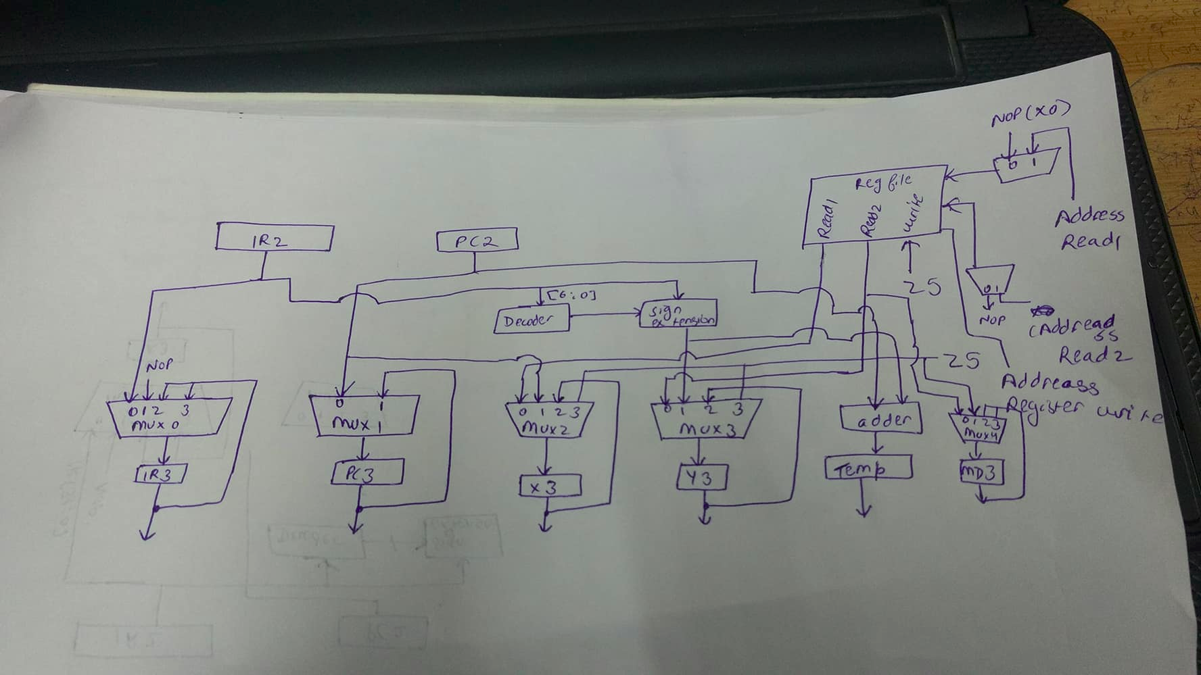
DECODE STAGE:

MUX 0: (Connected to IR3)

select = 1: NOP Instruction(If instruction has to be flushed)
select = 2-3: If instruction has to be stalled
select = 0 Otherwise

select = 1

IF stall has to be there than preceding instruction has to be passed to the 4th stage and following instruction must remain in the 2nd stage.

Therefore for stall case NOP instruction has to be put in the 3rd register i.e IR3

Therefore same conditions as that for stalling in select = 2 in Fetch stage for mux = 0.

Select = 2-3: If instruction has to be stalled

Not got any such case in which stall has to be done in the 3rd stage .

Select = 0: Otherwise

MUX 1 ( Connected to PC3 )

Select = 1 If stall has to be done
Select = 0 Otherwise

Select = 1: If stall has to be done

Same as select = 2 in Fetch stage for mux = 0

Select = 0: Otherwise

MUX 2 (Connected to X3)

Select = 0: Connected to Read1(For register read)
Select = 1: PC2 (For PC Relative computation)
Select = 2: X3 (For Stall)
Select = 3: Z5 (Forward Register)

Select = 0:

R – Type
Immediate arithmetic Instructions
LW / SW / JR / JALR

(IR2[6:0] == 0110011) || (IR2[6:0] == 0010011) || (IR2[6:0] == 0000011) || (IR2[6:0] == 0100011) || (IR2[6:0] == 1100111) || (IR2[6:0] == 1100011)

Select = 1

PC Relative Calculations (AUIPC or JAL)

( (IR2[6:0] == 0010111) || (IR2[6:0] == 1101111) )

Select = 2

When Stall has to be done

Same as select = 2 in Fetch stage for mux = 0

Select = 3

When forwarding has to be done from Z5 register

Lw rd, imm(rs1)
JALR rs1,rd,imm
(IR5[6:0] == 0000011) & (IR2[6:0]==1100111 && IR2[11:7] !=0) && (IR2[19:15]==IR5[11:7])

Lw rd,imm(rs1)
JR rd
(IR5[6:0] == 0000011) & (IR2[6:0] == 1100111 && IR2[11:7] == 0) & (IR5[11:7] == IR2[19:15] )

Lw rd, imm(rs1)
Beq rs1,rd,imm
(IR5[6:0] == 0000011) & (IR2[6:0] == 1100011) & (IR5[11:7] == IR2[19:15])

Lw rd,imm(rs1)
sw rs2,imm(rd)
IR5[6:0] == 0000011 & IR5[14:12] == 010 & IR2[6:0] == 0100011 & IR2[14:12] == 010
IR5[11:7] == IR2[19:15]

MUX 3 (Connected to Y3)

Select = 0: Read From Register
Select = 1: Sign Extension
Select = 2: Y3 (For Stall)
Select = 3: From Z5 (For Forwarding)

Select = 0:

For R-Type Instructions and for Branch Instructions

(IR2[6:0] == 0110011) || (IR2[6:0] == 1100011)

Select = 1: Sign Extension

For immediate instructions (JR/JALR/arithmetic immediates)

(IR2[6:0] == 0010011) || (IR2[6:0] == 1100111)

Select = 2: Y3 (For Stall)

When Stall has to be done

Same as select = 2 in Fetch stage for mux = 0

Select = 3: From Z5 (For Forwarding)

Lw rd,imm(rs1)
Add r3,rd,rs2

(IR5[6:0] == 0000011) &
(IR2[6:0] == 0010011) &(IR2[24:20]==IR5[11:7]) )

Lw rd, imm(rs1)
Beq rs1,rd,imm

(IR5[6:0] == 0000011) & (IR2[6:0] == 1100011) & (IR5[11:7] == IR2[24:20])

SIGN EXTENSION CONNECTED TO OUPUT OF DECODER:

Branch Instructions : B – Type
LUI / AUIPC : U – Immediate
Arrithmetic : I – immediate
LW – I – immediate
SW – S – immediate
JAL – J -immediate

MUX4: Connected to Register MD3 For Memory Write

Select 0 : Connected to Read port 2 for store instructions
Select 1 : Connected to Z5 for forwading
Select (2-3) : Connected for Stalling

Select = 0:

IR2[6:0] == 0100011

Select = 1 :

Lw rd,imm(rs2)
Sw rd,imm(rs1)

(IR2[24:20] == IR5[11:7]) & (IR2[6:0]==0100011) & (IR5[6:0]==0000011)

Select = (2-3)

When Stall has to be done
Same as select = 2 in Fetch stage for mux = 0

EXECUTE STAGE:

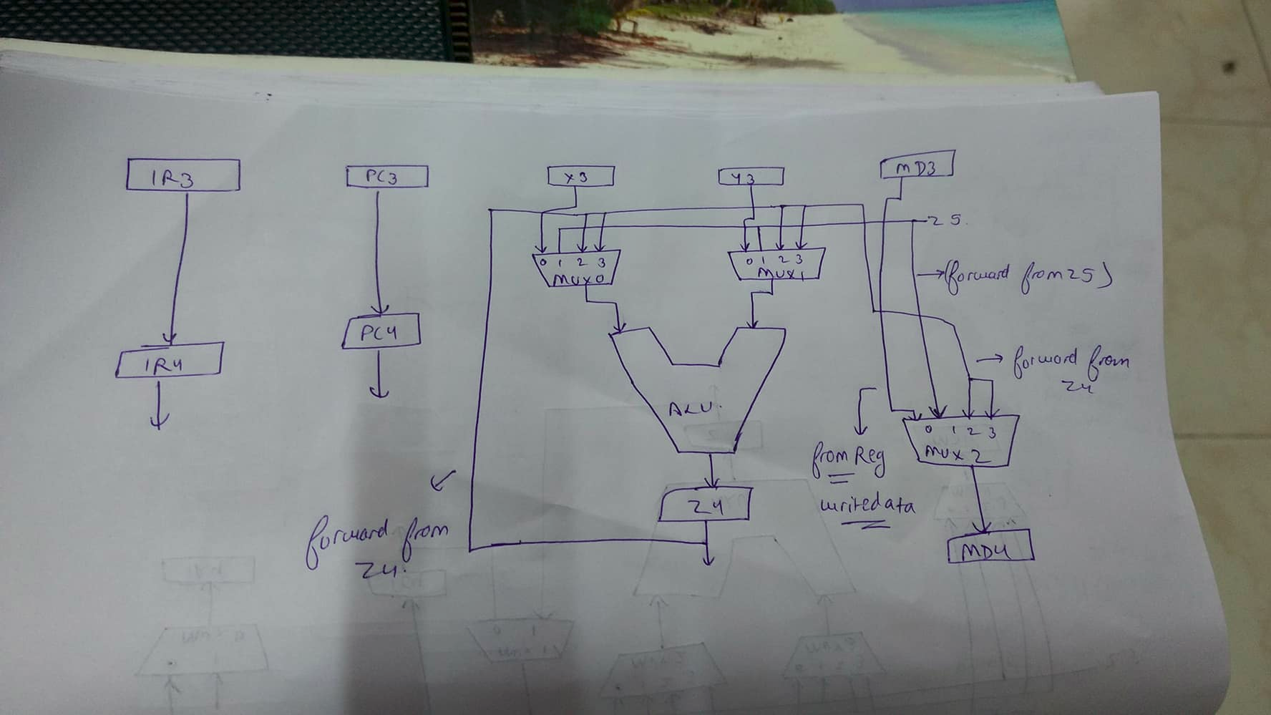

MUX 0:

Select = 1: Connected to Z5 Forwarding Register
Select = 2-3: Connected to Z4 Forwarding Regster
Select = 0: Otherwise

Select = 1

Lw rd, imm(rs1)
JALR rs1,rd,imm
IR5[6:0] == 0000011 & IR5[14:12] == 010 & IR3[6:0] == 1100111 & IR3[11:7] != 0 &
IR5[11:7] == IR3[19:15]

Lw rd,imm(rs1)
Jr rd
IR5[6:0] == 0000011 & IR5[14:12] == 010 & IR3[6:0] == 1100111 & IR3[11:7] == 0 &
IR5[11:7] == IR3[19:15]

Lw rd,imm(rs1)
add r3,rd,rs2 / addi
IR5[6:0] == 0000011 & IR5[14:12] == 010 & (IR3[6:0] == 0110011||IR3[6:0] == 0010011) &
(IR5[11:7] == IR3[19:15])

Lw rd, imm(rs1)
Beq rs1,rd,imm
IR5[6:0] == 0000011 & IR5[14:12] == 010 & IR3[6:0] == 1100011 & IR5[11:7] == IR3[19:15]

Lw rd,imm(rs1)
sw rs2,imm(rd)
IR5[6:0] == 0000011 & IR5[14:12] == 010 & IR3[6:0] == 0100011 & IR3[14:12] == 010
IR5[11:7] == IR3[19:15]

Select = 2-3 Connected to Z4 Forwarding Register

Add rd,rs1,rs2
sw rs2,imm(rd)
(IR4[6:0] == 0110011) & (IR3[6:0] == 0100011) & (IR4[11:7] == IR3[19:15])

Add rd, rs1 ,rs2
Jr rd
(IR4[6:0] == 0110011) & (IR3[6:0] == 11001111 & IR3[11:7] == 0) & (IR4[11:7]==IR3[19:15])

Add rd,rs1,rs2
Lw rs3,imm(rd)
(IR4[6:0] == 0110011) & (IR3[6:0] == 0000011) & (IR4[11:7] == IR3[19:15])

Add rd,rs1,rs2
Jalr rs3, rd, imm
(IR4[6:0] == 0110011) & (IR3[6:0] == 1100011 & IR3[11:7] !=0) & (IR4[11:7] == IR3[19:15])

Add rd,rs1,rs2
Addi rs2,rd,imm
(IR4[6:0] == 0110011) & (IR3[6:0] == 0010011) & (IR4[11:7] == IR3[19:15])

Add rd,rs1,rs2
Beq rd,rs3,imm
(IR4[6:0] == 0110011) & (IR3[6:0] == 1100011) & (IR4[11:7] == IR3[19:15])

Addi rd,rs1,imm
Add rs1,rd,rs2
(IR4[6:0] == 0110011) & (IR3[6:0] == 0000011) & (IR4[11:7] == IR3[19:15])

MUX1:

Select = 1: Connected to Z5 forwarding register
Select = 2-3: Connected to Z4 forwarding register
Select = 0: Otherwise

Select = 1

Lw rd,imm(rs1)
Add r3,rs1,rd

(IR5[6:0] == 0000011) &
(IR3[6:0] == 0010011) &(IR3[24:20]==IR5[11:7]) )

Lw rd, imm(rs1)
Beq rs1,rd,imm

(IR5[6:0] == 0000011) & (IR3[6:0] == 1100011) & (IR5[11:7] == IR3[24:20])

Select = 2 - 3

Add rd,rs1,rs2
Lw rs3,imm(rd)
(IR4[6:0] == 0110011) & (IR3[6:0] == 0000011) & (IR4[11:7] == IR3[19:15])

Add rd,rs1,rs2
Jalr rs3, rd, imm
(IR4[6:0] == 0110011) & (IR3[6:0] == 1100011 & IR3[11:7] !=0) & (IR4[11:7] == IR3[19:15])

Add rd,rs1,rs2
Beq rd,rs3,imm
(IR4[6:0] == 0110011) & (IR3[6:0] == 1100011) & (IR4[11:7] == IR3[19:15])

Addi rd,rs1,imm
Add rs1,rd,rs2
(IR4[6:0] == 0110011) & (IR3[6:0] == 0000011) & (IR4[11:7] == IR3[19:15])

MUX 2

Select 0: Connected from MD3 for data write (Sw instruction )
Select 1: Connected to Z5 for forwarding
Select 2-3 : Connected to Z4 for forwarding

Select = 1:

Lw rd,imm1
Sw rd,imm2
(IR5[6:0] == 0000011) & (IR3[6:0] == 0100011) & (IR5[11:7] == IR3[24:20])

Add rd,r1,r2 / Addi
Sw rd,imm
(IR5[6:0] == 0110011||IR5[6:0]==0010011) & (IR3[6:0] == 0100011) &
(IR5[11:7] == IR3[24:20])

Select = 2-3

Add rd,r1,r2 /Addi
Sw rd,imm
(IR4[6:0] == 0110011||IR4[6:0]==0010011) & (IR3[6:0] == 0100011) &
(IR4[11:7] == IR3[24:20])

ALU Instructions:

According to Opcode value

Memory Stage And Write Back Stage

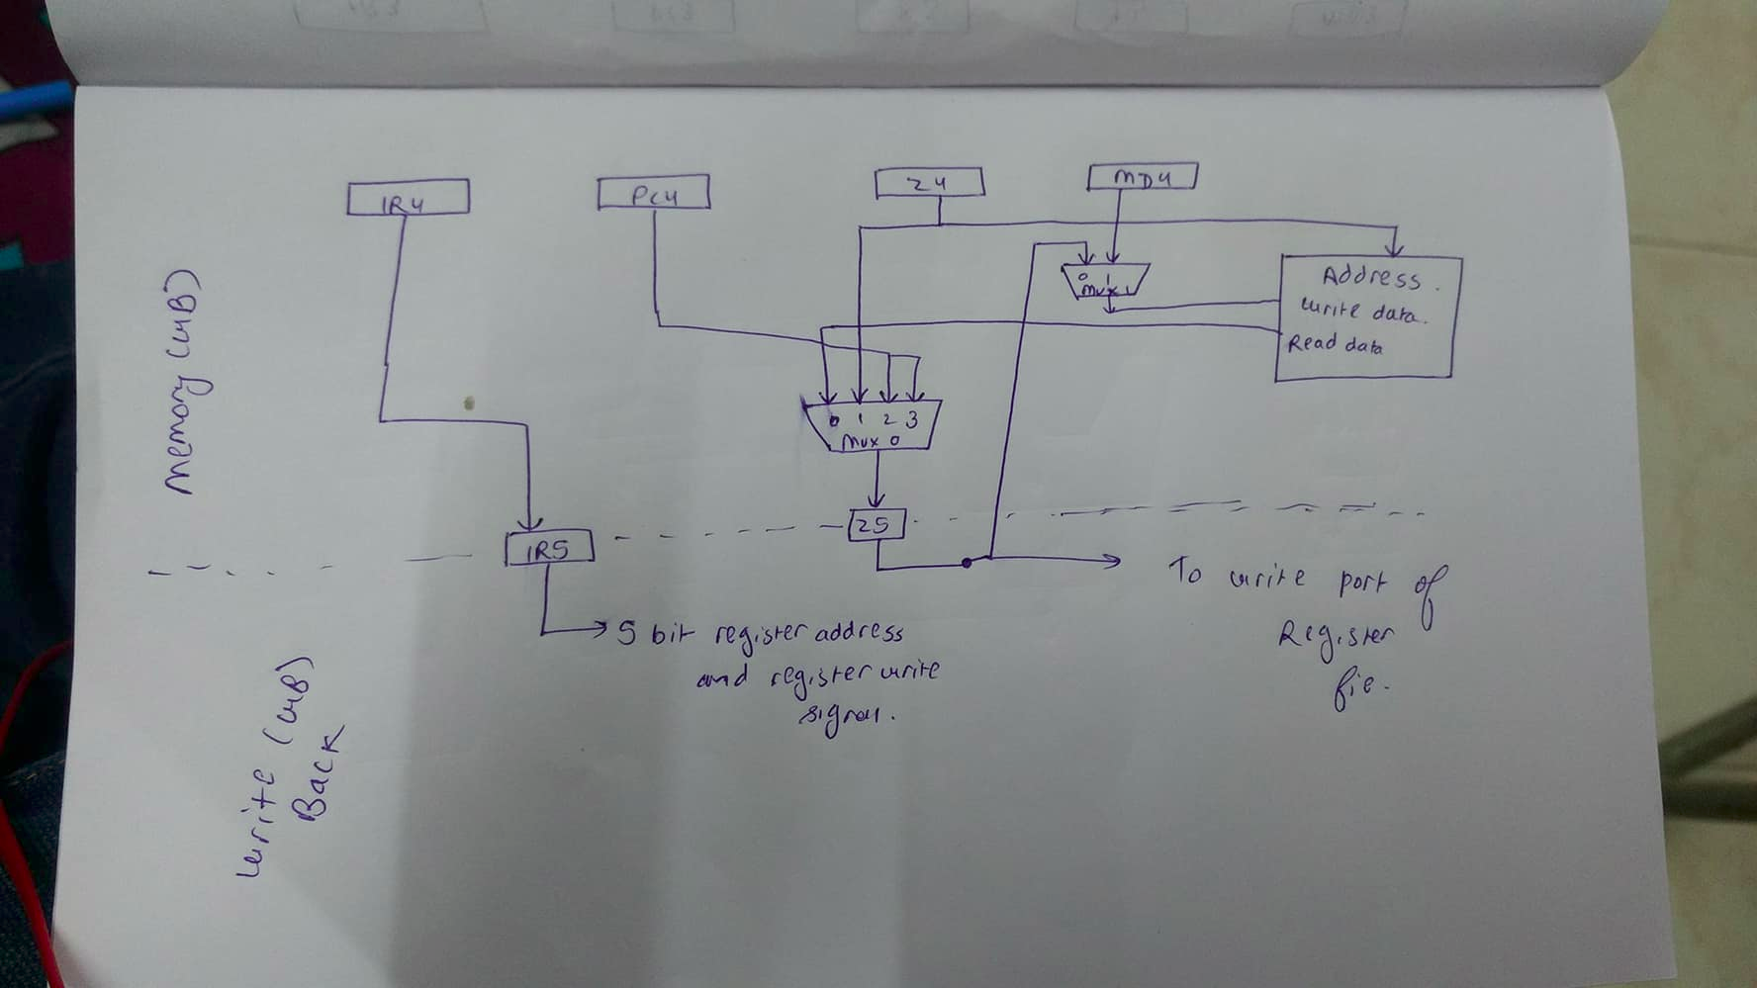

MUX0 :
Select = 0: Connected to read data (For load instructions)
Select = 1: Connected to Z4 (For arithmetic instructions)
Select = 2-3: Connected to PC4 For jump and link instructions

Select = 0:
IR4[6:0] == 0000011

Select = 1:
( IR4[6:0] == 0110011 ) || ( IR4[6:0] == 0010011 )

Select = 2-3:
(IR4[6:0] == 1101111 || IR4[6:0] == 1100111) & ( IR4[11:7] != 0)

MUX1 :

Select = 0: Connected to MD4
Select = 1: Connected to Z5 for forwarding

Select = 1

lw rd, imm(rs1)
sw rd,imm(rs2)
(IR5[6:0] == 0000011) & (IR4[6:0] == 0100011) & (IR5[11:7] == IR4[24:20])

Select = 0

Otherwise

Write signal to memory True only when instruction is Sw
IR4[6:0] == 0100011

WRITE BACK STAGE:

Write Signal for register file holds true if instruction is of R – type or I – type or jump and link instructions
IR5[6:0] == 0110011 || IR5[6:0] == 0010011 || (IR5[6:0] == 1101111) || (IR5[6:0] == 1100111 & IR5[11:7] ! = 0)

